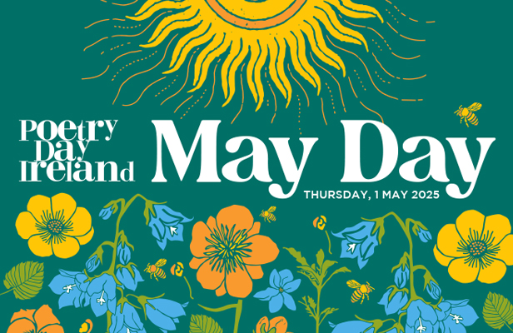

11am Joanne McCarthy poetry workshop

1pm Top of the City Community Gardens w Louis Quinlan and other performers to be confirmed and music from Paula Marksith

2pm The Waxed Lemon at WGOA
3pm Poetry workshop with Mount Sion Secondary School with Wayne Power TBC

3.30opm A Celebration of Sean Dunne curated by Martina Coillendar at Theatre Royal vestibule

4pm The Poetry Lounge at The Book Centre with Ger Duffy -20 poets from Mark Roper to Frank Farrelly

6pm Poetry Day Rocks at Luca Records with Bonya , Porcelain Eyes, Elcaro , £rd Degree

7pm Tullys Open Mic Poetry Day special hosted by comedian Conor Roche

8pm Waterford Writers open mic at The Mansion House

8.30pm -11pm Slip of the Tongue at Phil Grimes charity event with Mikey Cullen , Lauren Macnamara and Bonya. All proceeds to go to , Waterford Marine search and Rescue, Aware , Samaritans. Will also include Derek and Nicola Spendlove , and Mary O Donoghue

Budget breakdown

TOP OF THE CITY COMMUNITY GARDENS - €100.00
GER DUFFY €75.00
MARTINA COLLENDAR – tbd
LUCA RECORDS – Will give €100 to charity Slip of the Tongue
THE WAXED LEMON - €500
JOANNE MCCARTHY WORKSHOP – TBD
EDDIE BLAKE -€300.00
TULLYS -€100.00
MIKEY CULLEN - €140
LAUREN MACNAMARA - €140
BONYA - €300
NICOLA SPENDLOVE - €150

ROUGH TOTAL - €1805.00
REMAINDER - -€1695.00

