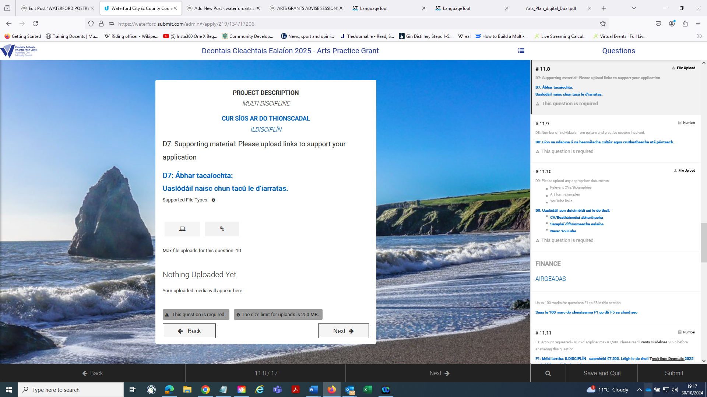
Click the link icon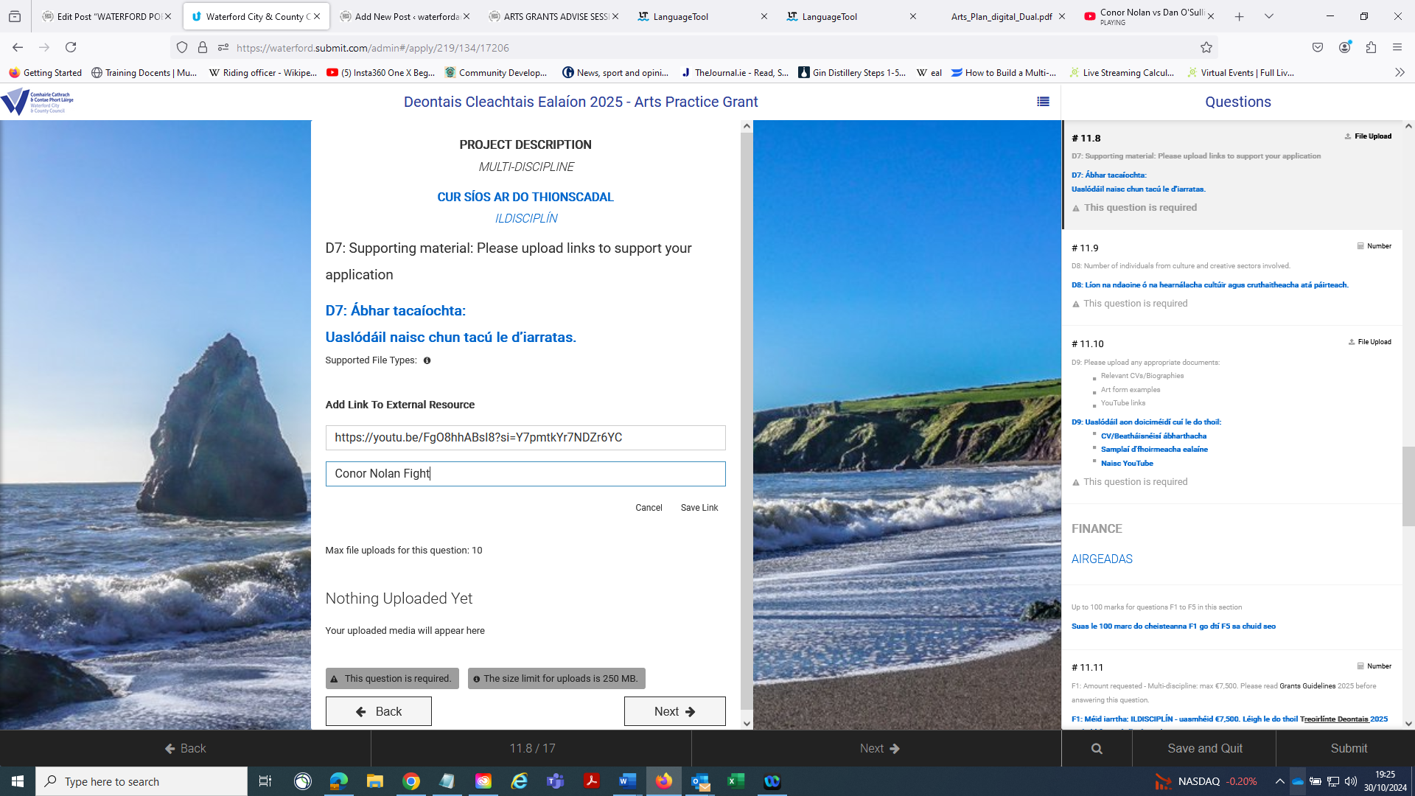
Use any of your Youtube video links in the box and give it a name and press return
Alternatively Copy any Youtube link and insert it (don’t put in anything silly – despite my example LOL). In the description put in type in “Work around”.

